# ACKNOWLEDGEMENT

We are thankful to a great many people who have helped us and supported us during our project work.We express our thanks ***to Ms.P.Y.Desai***, the I/C Principal **of J.P.Dawer Institute of Msc(IT) & Msc(ICT),** and **Dr.kamlendu Pandey** the Coordinator of our college for extending his support. We would not miss the opportunity to thank our Project We would also like to thank our faculty members and project guide, **Sunny Chevli** . He has always provided continuous guidance without his assistance this would not have been possible. & Support and has always been a stepping stone in completing this Project have been a distant reality. We also extended our heartfelt thanks to our family members and well-wishers.

Yours Sincerely,

Bhagyashree Dungarwal(10004)

Sujeet Maurya(10014)

Meet Mistry(10016)

#### Chapter1. Introduction

* 1. Company Profile



**InfoWeb Solution**

InfoWeb Solution is the leading IT Solutions company based in Surat, India. Since 2012, InfoWeb Solution is a IT Firm which combines beautiful interactive design with intelligent technology such as .NET and REACT and other JavaScript Framework. Here at Speed Limit, InfoWeb Solution understand that having a great website, a print piece, or even a beautiful logo is just not enough. You need results. InfoWeb Solution is a result-focused company. InfoWeb Solution love’s tying in creative marketing campaigns to our great work.

**Address:-** 25, Vatsalya Bunglows, Near S.D Jain Modern School, Vesu, Surat - 395007

**Contact No.:-** +91 99092 84838

**Email:-** [sunnychevli@gmail.com](mailto:sunnychevli@gmail.com)

* 1. Customer Profile

1.1.1 Customer Detail

The Live Score project provides an engaging platform for viewers to follow Taekwondo tournaments in real-time. Viewers can access live match details and scores, ensuring they stay updated on the latest events and outcomes. The system leverages SignalR for real-time updates, offering an immersive experience with up-to-the-minute information on ongoing matches. This user-friendly interface allows viewers to effortlessly track their favorite athletes and matches without any management responsibilities.

Viewers benefit from a seamless and intuitive interface that prioritizes ease of access and real-time information. The platform's design ensures that all live scores, match progress, and outcomes are displayed promptly, keeping viewers engaged and informed. With the integration of SignalR, updates are instantaneous, providing a dynamic experience that mirrors the excitement of watching the matches live. Whether following individual athletes or entire tournaments, viewers can enjoy a comprehensive overview of all the action, making the Live Score project an indispensable tool for Taekwondo enthusiasts.

* 1. Current System

The Live Score project is tailored for various stakeholders involved in Taekwondo tournaments:

* Admins:

Responsible for managing categories, tournaments, coordinators, matches, and historical data. They oversee the entire system ensuring smooth operations.

* Coordinators:

Handle athlete registrations, match scheduling, referee assignments, coach management, and scoring details. They act as the backbone of the tournament organization.

* Referees:

Focus on live scoring during matches and ensure fair play. They have the ability to update their personal profiles.

* Viewers:

Public users who access the platform to view real-time match details and scores. They do not have any management responsibilities but benefit from live updates facilitated by SignalR integration.

The system ensures secure authentication using JWT tokens and supports essential user functions such as login, logout, registration, and password recovery via email services.

**Chapter2. Proposed System**

* 1. Scope

The Live Score project aims to streamline Taekwondo tournament management and viewing experiences. It encompasses functionalities for Admins, Coordinators, Referees, and Viewers, ensuring efficient operations and real-time updates. Utilizing .NET Core API and React with Redux, the system offers secure authentication, seamless communication via SignalR, and robust database management. Admins oversee categories, tournaments, and Coordinator verification, while Coordinators manage athletes, matches, and scoring. Referees handle real-time scoring, and Viewers access live match details effortlessly. Overall, the project optimizes tournament management and enhances the viewing experience for all stakeholders.

* 1. Objective

The primary objective of the “Live Score” project is to provide a comprehensive and efficient solution for managing and viewing Taekwondo tournaments. This entails:

* Streamlining tournament logistics through functionalities tailored for Admins and Coordinators, including category and tournament management, athlete registration, match scheduling, and scoring oversight.
* Facilitating real-time communication via SignalR to ensure viewers receive live match details and scores instantly, enhancing their engagement and experience.
* Offering a user-friendly interface for both administrators and viewers, allowing easy access to relevant information and functionalities without compromising on security.
* Providing viewers with a dynamic platform to access live match details seamlessly, promoting a richer viewing experience.
  1. Constraints :

The Live Score project operates within several constraints that shape its development and implementation. Time constraints present a challenge, requiring efficient management of development, testing, and deployment phases to meet project deadlines. Resource limitations, including human, financial, and technological resources, may restrict the project's ability to scale or implement advanced features.

Additionally, technical constraints such as dependencies on external APIs and regulatory compliance requirements impose further limitations on development efforts. Despite these challenges, proactive management and prioritization of stakeholder expectations can help mitigate constraints and ensure the successful delivery of a streamlined and engaging Taekwondo tournament management and viewing platform.

* + 1. H/w Constraints :

1. Server Specification:

* Limited hardware resources may impact the performance and scalability of the application. The server specification, including CPU, RAM, and disk space, must be sufficient to handle concurrent user requests and real-time updates effectively.

1. Network Infrastructure:

* The network infrastructure, including bandwidth capacity and network latency, influences the responsiveness and reliability of real-time communication features such as SignalR. Constraints in network bandwidth or high latency may result in delays or interruptions in live score updates.

1. Storage System:

* Constraints in storage capacity and performance of the storage system, whether it's a local disk or a cloud-based solution, may affect the system's ability to store and retrieve data efficiently.

1. Security Hardware:

* Constraints in security hardware, such as firewalls, intrusion detection systems, and encryption accelerators, may impact the system's ability to protect sensitive user data and prevent unauthorized access or attacks.

1. Cost Constraints:

* Consider budgetary constraints when selecting hardware. Optimize the hardware configuration to meet project requirements within budgetary limits.
  + 1. S/W Constraints:

1. Database Management System:
   * The Live Score project's software constraints revolve around its Database Management System (DBMS). Compatibility with SQL Server Management Studio (SSMS), scalability for handling large datasets, and security measures are key considerations.
2. Operating System:
   * Compatibility with various operating systems like Windows, Linux, and macOS is essential for broad accessibility.
3. Framework and Dependency Limitations:
   * Compatibility issues between different versions of frameworks or dependencies may impact development and deployment flexibility.
4. Licensing Restrictions:
   * + - * Compliance with software licensing agreements is necessary to avoid legal complications and ensure sustainability.
5. Performance Constraints:
   * + - * Performance limitations of software components could affect overall system performance and scalability.
6. Security Vulnerabilities:

* Risks associated with software security vulnerabilities require proactive measures to ensure data integrity and confidentiality.
  1. Advantages
* SQL Server Management Studio (SSMS) is a robust and scalable platform for managing relational databases, offering advanced features like stored procedures and triggers.
* SSMS Integration with other Microsoft technologies provides seamless compatibility and support.
* React and Redux Component-based architecture of React allows for modular and reusable code, enhancing development efficiency.
* Redux facilitates centralized state management, simplifying data flow and improving application scalability..
* .NET Core API is a Cross-platform compatibility of .NET Core allows for deployment on various operating systems, enhancing flexibility.
* Strong integration with other Microsoft technologies and libraries streamlines development and reduces compatibility issues.

* 1. Limitation
* The database SSMS Licensing costs associated with SQL Server may be prohibitive for smaller projects or organizations.
* .NET Core AP Limited support for certain third-party libraries and frameworks compared to other languages like Node.js or Python.

**Chapter3. Environment Specification**

3.1 Hardware & Software Requirements

HARDWARE SPECIFICATION

* Processor: 12th Gen Intel Core i3 1.20 GHz
* Ram : 8 GB

### SOFTWARE SPECIFICATION

* Operating System: - Windows 10 ,11
* Front S/W: React, Redux
* Back S/W: .Net Core API
* Database: SQL Server Management Studio (SSMS)

3.2 Development Description

The development of the Live Score project is a comprehensive process involving careful planning, design, implementation, testing, and deployment. By adhering to a structured approach and utilizing modern tools and technologies, the project aims to deliver a robust and efficient system for managing Taekwondo tournaments with real-time score updates and seamless user experience for all roles involved.

The development team will follow a systematic approach:

1. Requirement Analysis:

The initial phase involved gathering requirements from stakeholders, understanding the intricacies of Taekwondo scoring, and outlining the roles and functionalities needed for Admin, Coordinator, Referee, and Viewer.

1. System Design:

The architecture of the system was designed. This included defining the database schema, setting up the backend and frontend architectures, and designing the APIs. The system was structured to ensure scalability, reliability, and real-time capabilities. The use of SQL Server Management Studio (SSMS) for the database, .NET Core for the backend, and React with Redux for the frontend were finalized.

1. Database Development:

The database was developed using SQL Server Management Studio (SSMS). Tables were created to manage athletes, matches, referees, coaches, scores, and rounds. Stored procedures were implemented to handle complex business logic efficiently.

1. Backend Development:

The backend was developed using .NET Core API. This included creating APIs for all functionalities such as user management, match management, score management, and more. JWT tokens were implemented for secure API authentication. SignalR was integrated to handle real-time updates for live scores and round management. Temporary memory management was also implemented to optimize the handling of transient data during live operations.

1. Frontend Development:

The frontend was developed using React and Redux. Components were created for various roles such as Admin, Coordinator, Referee, and Viewer. The frontend communicated with the backend APIs to fetch and display data dynamically. Real-time updates were managed using SignalR to ensure viewers received live scores without needing to refresh the page.

1. Integration and Testing:

Extensive testing was conducted to identify and fix bugs. Unit tests, integration tests, and end-to-end tests were performed to ensure the system met all requirements and functioned correctly under various scenarios.

1. Deployment Configuration:

The system was deployed on a server with a suitable operating system (Windows Server or a compatible Linux distribution). IIS or Nginx/Apache was configured as the web server.

**Chapter4. System Planning**

* 1. Feasibility Study

The Live Score project is feasible across all key components, promising a valuable tool for Taekwondo event management and live scoring.

Key components:

1. Project Scope and Objectives:
   * + The system supports four user roles—Admin, Coordinator, Referee, and Viewer—each with distinct functionalities. Key objectives include real-time score updates, efficient match management, secure user authentication, and seamless user experience across roles.

1. Market Analysis:
   * + The demand for real-time sports scoring and management systems is growing, driven by increasing digital engagement in sports. Target users include sports organizations, Taekwondo clubs, event coordinators, referees, athletes, and spectators.
2. Technical Feasibility:
   * + The project leverages robust and scalable technologies such as .NET Core for backend, React and Redux for the frontend, and SSMS for database management. Real-time communication is facilitated by SignalR and use of JWT Tokens and email services ensures secure and reliable user authentication and account management.
3. Legal and Ethical Feasibility:
   * + The project complies with data protection regulations such as GDPR and CCPA, ensuring user data privacy and security. Ethical considerations include fair play, transparency in scoring, and non-discriminatory practices.
4. Operational Feasibility:
   * + The operational workflow integrates seamlessly with existing sports event management practices. Admins and coordinators can easily manage categories, tournaments, and personnel, while referees can efficiently handle scoring during matches. Viewers benefit from intuitive access to live.
   1. Software Engineering Model

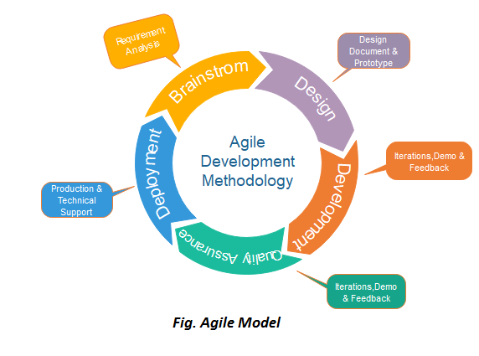

* The meaning of Agile is swift or versatile."**Agile process model**" refers to a software development approach based on iterative development.
* Agile methods break tasks into smaller iterations, or parts do not directly involve long term planning.
* The project scope and requirements are laid down at the beginning of the development process.
* Plans regarding the number of iterations, the duration and the scope of each iteration are clearly defined in advance.
* Each iteration is considered as a short time "frame" in the Agile process model, which typically lasts from one to four weeks.
* The division of the entire project into smaller parts helps to minimize the project risk and to reduce the overall project delivery time requirements.
  1. Risk Analysis

While the Live Score project presents several risks, these can be effectively managed through careful planning, robust security measures, thorough testing, and proactive mitigation strategies.

1. Technical Risks:
   * + System Downtime, Scalability Issues and Integration Challenges various technologies (e.g., .NET Core, SignalR, React, SQL Server) may result in compatibility issues
     + Mitigation: Implement redundant servers and robust backup systems to ensure high availability and reliability and use well-documented integration practices to ensure seamless interaction between components.
2. Project Management Risks:
   * + Timeline Delays such as Unforeseen issues may delay the project timeline, impacting delivery schedules. and Team Coordination.
     + Mitigation: Use agile project management practices, regular progress reviews, and contingency planning to stay on track
3. Operational Risks:
   * + User Adoption and **Data Accuracy like** Inaccurate data entry by referees or coordinators could lead to incorrect scores and match outcomes.
     + Mitigation: Implement validation checks and provide user training to ensure accurate data entry.
4. Security Risk:
   * + Data Breaches Unauthorized access to sensitive data and **Authentication Failures** weak authentication mechanisms could lead to unauthorized access.
     + Mitigation: Implement strong encryption, secure authentication (JWT Tokens)
5. Legal and Compliance:
   * + Regulatory Compliance like Non-compliance with data protection laws old result in legal penalties and Intellectual Property
     + Mitigation: Regularly review and update compliance practices to ensure adherence to relevant regulations.
   1. Project Schedule
      1. Task Dependency:

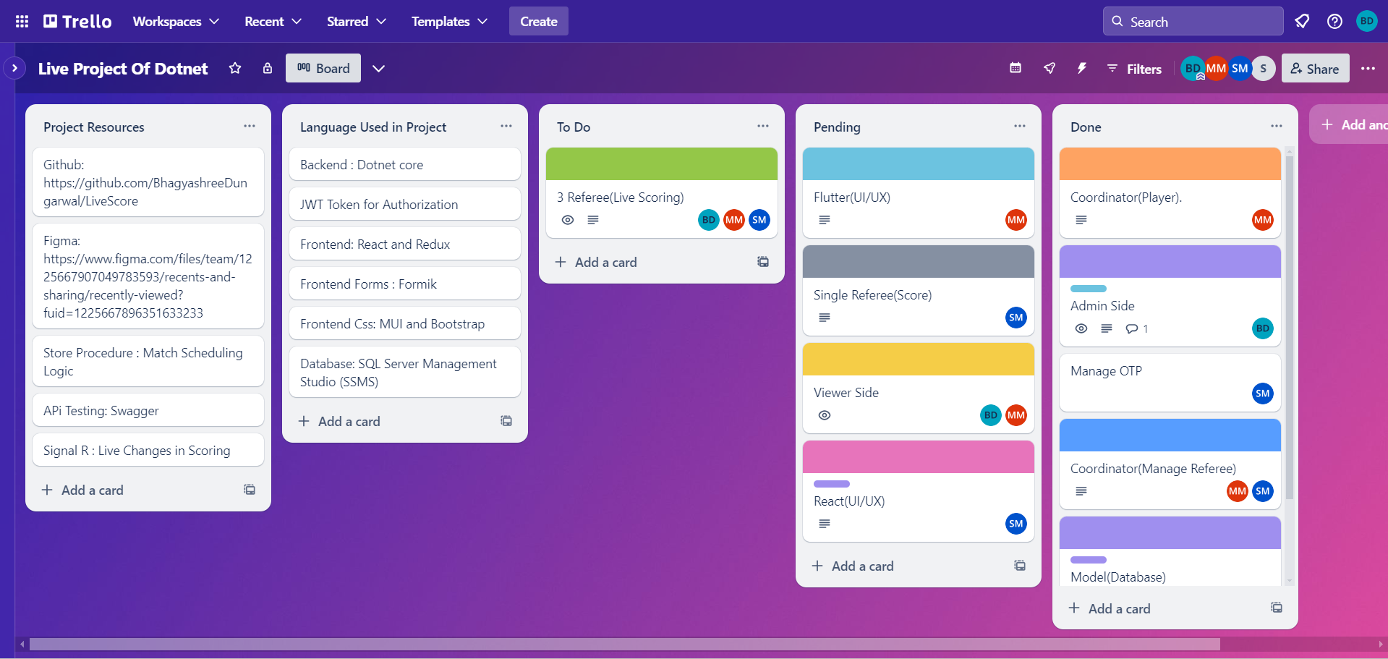

* + 1. Timeline Chart

|  |  |  |  |  |  |  |  |  |  |  |  |  |  |  |  |  |
| --- | --- | --- | --- | --- | --- | --- | --- | --- | --- | --- | --- | --- | --- | --- | --- | --- |
| **Task** | **Jan-Feb** | | | | **Mar-April** | | | | **May** | | | | **June** | | | |
| 1. **1) Initial Planning** |  |  |  |  |  |  |  |  |  |  |  |  |  |  |  |  |
| 1. Identify Project and their requirements |  |  |  |  |  |  |  |  |  |  |  |  |  |  |  |  |
| 1. Develop project timeline |  |  |  |  |  |  |  |  |  |  |  |  |  |  |  |  |
| 1. Assign roles and responsibilities to team 2. members |  |  |  | 1. d |  |  |  |  |  |  |  |  |  |  |  |  |
| 1. **Milestone: Define the project scope &** 2. **objectives** |  |  |  |  |  |  |  |  |  |  |  |  |  |  |  |  |
| 1. **2) Planning** |  |  |  |  |  |  |  |  |  |  |  |  |  |  |  |  |
| Identify project risks & develop mitigation  strategies |  |  |  |  |  |  |  |  |  |  |  |  |  |  |  |  |
| Define project deliverables and timelines |  |  |  |  |  |  |  |  |  |  |  |  |  |  |  |  |
| Develop a detailed project schedule |  |  |  |  |  |  |  |  |  |  |  |  |  |  |  |  |
| **Milestone: Develop a high-level project**  **plan** |  |  |  |  |  |  |  |  |  |  |  |  |  |  |  |  |
| **3) Requirements Analysis & Design**  **Designing** |  |  |  |  |  |  |  |  |  |  |  |  |  |  |  |  |
| Conduct user research and identify  requirements |  |  |  |  |  |  |  |  |  |  |  |  |  |  |  |  |
| Develop user stories and acceptance criteria |  |  |  |  |  |  |  |  |  |  |  |  |  |  |  |  |
| Develop system architecture and design |  |  |  |  |  |  |  |  |  |  |  |  |  |  |  |  |
| **Milestone: Designing completed** |  |  |  |  |  |  |  |  |  |  |  |  |  |  |  |  |
| **4) Implementation** |  |  |  |  |  |  |  |  |  |  |  |  |  |  |  |  |
| Develop code for core functionality |  |  |  |  |  |  |  |  |  |  |  |  |  |  |  |  |
| Conduct code reviews and testing |  |  |  |  |  |  |  |  |  |  |  |  |  |  |  |  |
| Document system design and implementation |  |  |  |  |  |  |  |  |  |  |  |  |  |  |  |  |
| **Milestone: Coding completed** |  |  |  |  |  |  |  |  |  |  |  |  |  |  |  |  |
| **5) Development** |  |  |  |  |  |  |  |  |  |  |  |  |  |  |  |  |
| Develop code for additional features |  |  |  |  |  |  |  |  |  |  |  |  |  |  |  |  |
| Conduct code reviews and testing |  |  |  |  |  |  |  |  |  |  |  |  |  |  |  |  |
| Document system design and implementation |  |  |  |  |  |  |  |  |  |  |  |  |  |  |  |  |
| **Milestone: Development completed** |  |  |  |  |  |  |  |  |  |  |  |  |  |  |  |  |
| **6) Testing** |  |  |  |  |  |  |  |  |  |  |  |  |  |  |  |  |
| **Develop test plans and cases** |  |  |  |  |  |  |  |  |  |  |  |  |  |  |  |  |
| **Conduct unit, integration, and system testing** |  |  |  |  |  |  |  |  |  |  |  |  |  |  |  |  |
| **Document testing results and defect** |  |  |  |  |  |  |  |  |  |  |  |  |  |  |  |  |
| **Milestone: Testing completed** |  |  |  |  |  |  |  |  |  |  |  |  |  |  |  |  |

**Chapter5. System Analysis**

* 1. Detailed SRS

Software Requirements Specification (SRS) for your LiveScore project involves documenting various aspects such as functional requirements, non-functional requirements, and constraints. Below is a structured table-based format for the SRS, incorporating key details from the tables and project description provided:

1. Functional Requirements:

* Admin Management:

|  |  |
| --- | --- |
| **Requirement ID** | **Requirement Description** |
| **FR-ADM-01** | Admins can manage categories including adding, editing, and deleting categories. |
| **FR-ADM-02** | Admins can manage tournaments including scheduling, updating details, and assigning coordinators. |
| **FR-ADM-03** | Admins can verify coordinators by reviewing their credentials and approving/rejecting their requests. |
| **FR-ADM-04** | Admins can view match details including participants, scores, and match history. |

* Coordinator Management:

|  |  |
| --- | --- |
| **Requirement ID** | **Requirement Description** |
| **FR-COORD-01** | Coordinators can manage athletes including registration, updating details, and assigning to categories. |
| **FR-COORD-02** | Coordinators can manage matches including scheduling, updating match details, and assigning referees. |
| **FR-COORD-03** | Coordinators can manage referees including assigning matches and reviewing performance. |
| **FR-COORD-04** | Coordinators can manage coaches including adding, updating, and assigning to athletes. |
| **FR-COORD-05** | Coordinators can manage scoring during matches including entering points and penalties. |
| **FR-COORD-06** | Coordinators can manage rounds including scheduling, timing, and recording scores. |

* Referee Management

|  |  |
| --- | --- |
| **Requirement ID** | **Requirement Description** |
| **FR-REF-01** | Referees can manage scoring during matches including entering points and penalties. |
| **FR-REF-02** | Referees can manage rounds including recording round results and winner. |

* Viewer Management

|  |  |
| --- | --- |
| **Requirement ID** | **Requirement Description** |
| **FR- VIEW-01** | Viewers can access live match scores and updates in real-time using SignalR.. |
| **FR- VIEW-02** | Viewers can view past match results and historical data. |

1. Non-Functional Requirements

|  |  |
| --- | --- |
| **Requirement ID** | **Requirement Description** |
| **NFR -01** | The system shall ensure high availability and performance during peak usage times. |
| **NFR -02** | The system shall maintain data consistency and integrity across all transactions. |
| **NFR -03** | The system shall be secure with data encryption and user authentication using JWT tokens. |
| **NFR -04** | The system shall provide a responsive and user-friendly interface using React and Redux. |
| **NFR -05** | The system shall comply with GDPR regulations for user data privacy and protection. |

1. Constraints

|  |  |
| --- | --- |
| **Requirement ID** | **Requirement Description** |
| **CON-01** | The system shall be developed using .NET Core for backend APIs. |
| **CON-02** | The system shall use SQL Server Management Studio (SSMS) for database management. |
| **CON-03** | The system shall utilize SignalR for real-time score updates and round management. |
| **CON-04** | The system shall implement stored procedures for business logic and data manipulation. |

* 1. UML Diagram
     1. Use Case Diagram
* Admin UML:

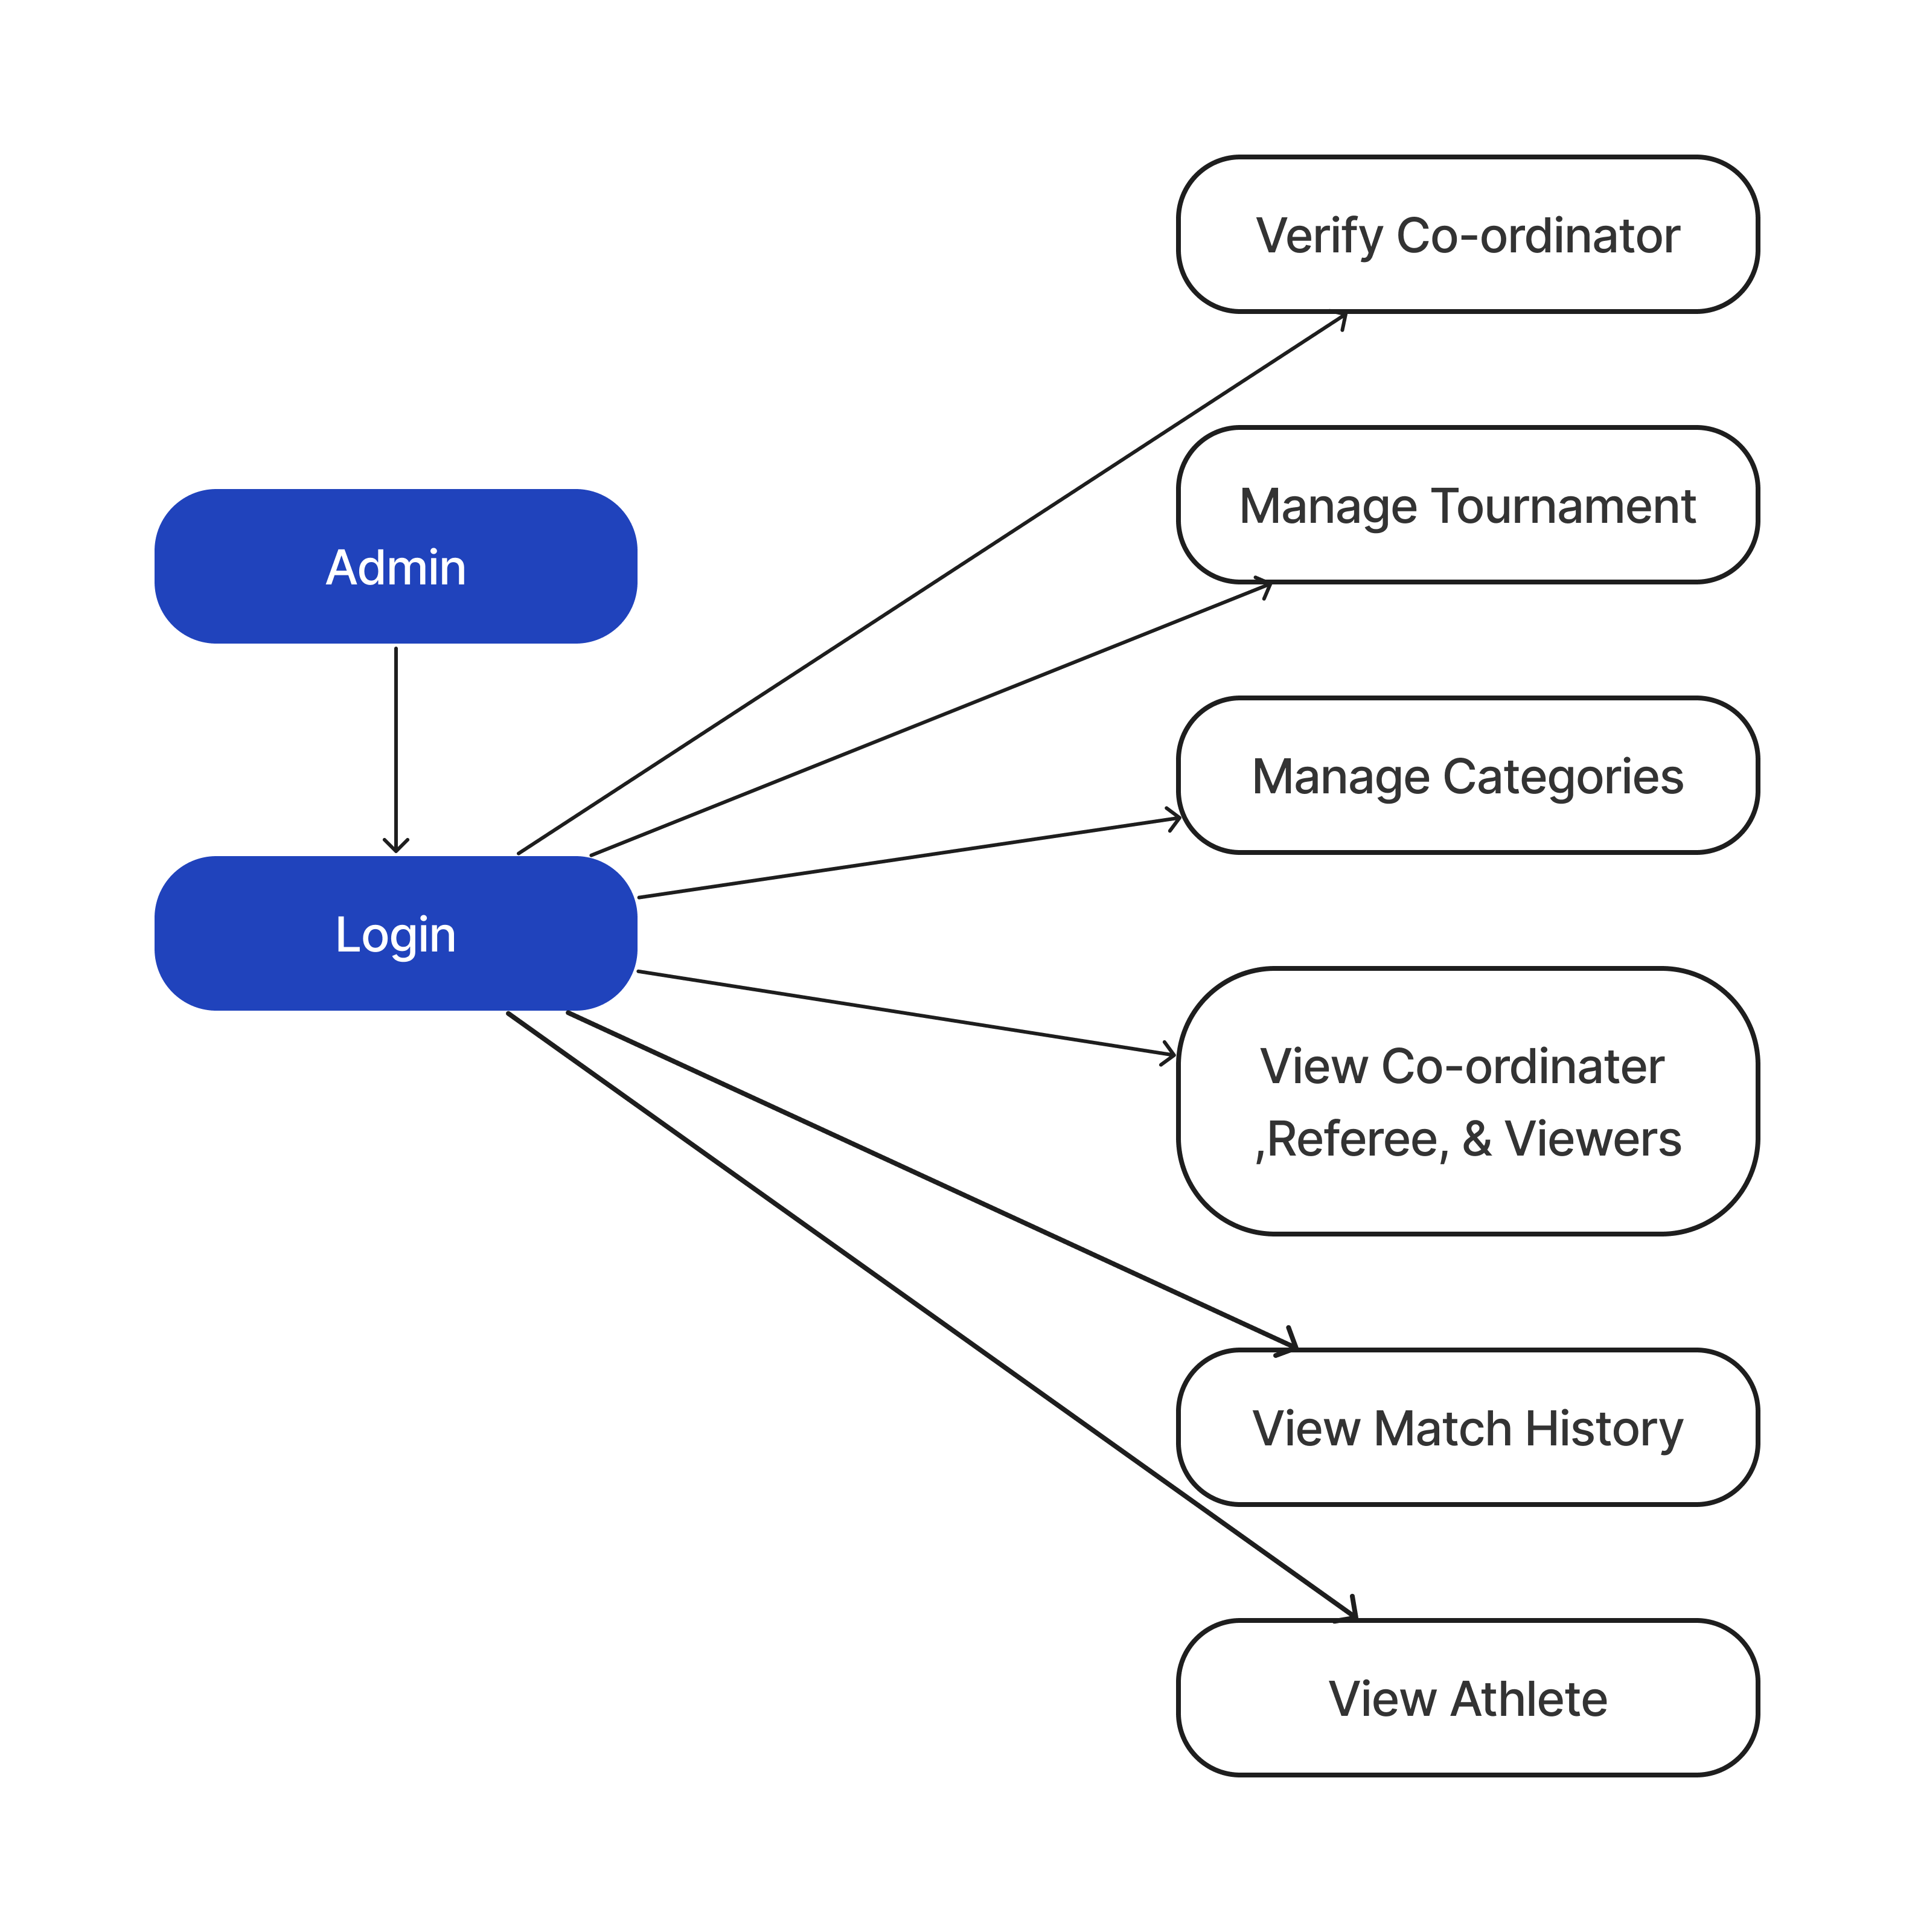

* Coordinator UML:

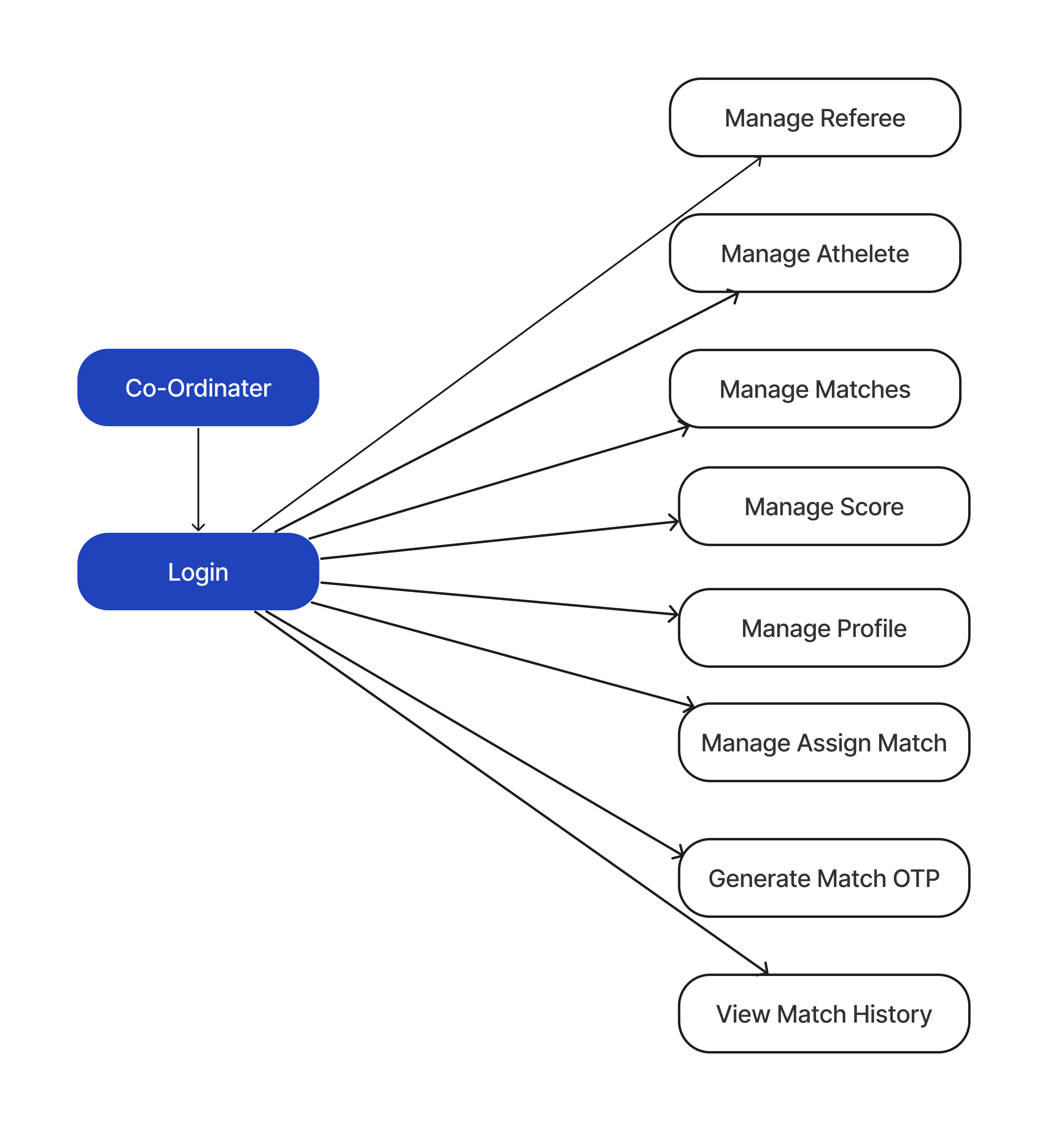

* Referee UML:

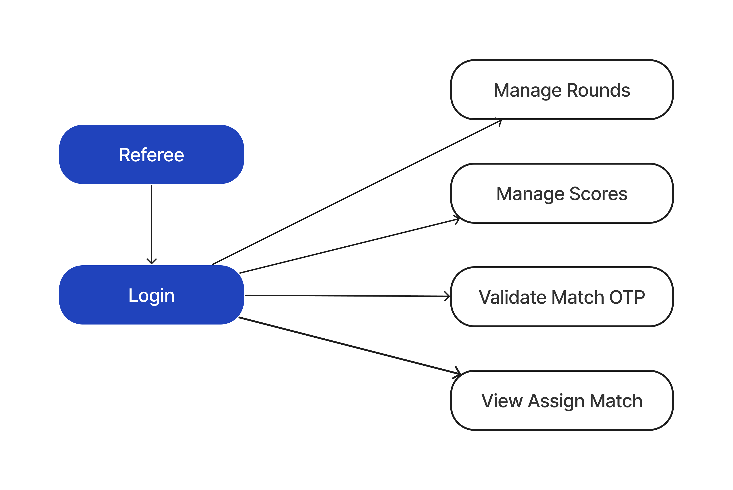

* + 1. Activity Diagram
* Admin Activity:

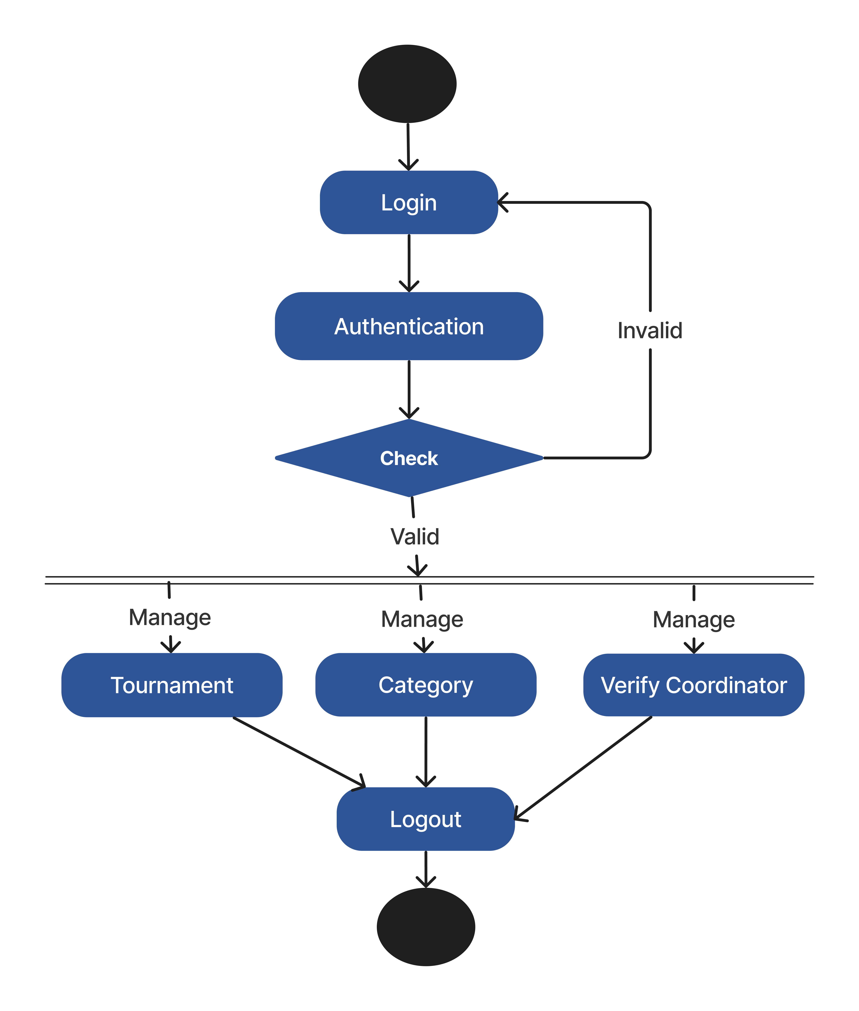

* Coordinator Activity:



* 1. E-R Diagram



**Chapter6. Software** **Design**

* 1. Database Design
* ACR Table : (Admin, Coordinator and Referee)

|  |  |  |  |
| --- | --- | --- | --- |
| Field | Type | Description | Constraint |
| Id | int | Primary key | Primary key, auto-generated |
| Email | nvarchar(101) | Email address | Not null |
| Name | nvarchar(101) | Name | Not null |
| Password | nvarchar(101) | Password | Not null |
| ImageURL | nvarchar(max) | URL to profile image | Not null |
| Contact | nvarchar(101) | contact number | Not null |
| Status | nvarchar(max) | status (e.g., Pending, Live etc) | Not null |
| DateOfBirth | datetime2(7) | Date of birth | Not null |
| Age | int | Age | Not null |
| LastLogin | datetime | Date and time of last login | Nullable |
| Gender | nvarchar(101) | Gender | Nullable |
| City | nvarchar(101) | City | Nullable |
| State | nvarchar(101) | State | Nullable |
| RoleId | int | Foreign key to Roles table | Foreign key to Roles(Id) |

* Role Table:

| Field | Type | Description | Constraint |
| --- | --- | --- | --- |
| Id | int | Primary key | Primary key, auto-generated |
| role | nvarchar(101) | Role name | Nullable |

* Category Table:

| Field | Type | Description | Constraint |
| --- | --- | --- | --- |
| Cid | int | Primary key | Primary key, auto-generated |
| CategoryName | nvarchar(101) | Name of the category | Not null |
| MinWeight | int | Minimum weight for the category | Not null |
| MaxWeight | int | Maximum weight for the category | Not null |
| Gender | nvarchar(10) | Gender associated with the category | Nullable |
| MinAge | int | Minimum age for the category | Not null |
| MaxAge | int | Maximum age for the category | Not null |

* Coach Table:

| Field | Type | Description | Constraint |
| --- | --- | --- | --- |
| CoachId | int | Primary key | Primary key, auto-generated |
| CoachName | nvarchar(101) | Name of the coach | Not null |
| Gender | nvarchar(101) | Gender of the coach | Not null |
| ImageUrl | nvarchar(max) | URL to coach's profile image | Not null |
| CoachEmail | nvarchar(101) | Email address of the coach | Not null |
| ContactNo | nvarchar(101) | Contact number of the coach | Not null |
| Status | nvarchar(101) | Status of the coach (e.g., active) | Nullable |
| Experience | nvarchar(101) | Coach's experience details | Not null |
| Achievements | nvarchar(101) | Coach's achievements | Not null |

* Athlete Table:

|  |  |  |  |
| --- | --- | --- | --- |
| Field | Type | Description | Constraint |
| Id | int | Primary key | Primary key, auto-generated |
| AthleteName | nvarchar(101) | Name of the athlete | Not null |
| Email | nvarchar(101) | Email address of the athlete | Not null |
| Contact | nvarchar(101) | Contact number of the athlete | Not null |
| ImageUrl | nvarchar(max) | URL to athlete's profile image | Not null |
| DateOfBirth | datetime2(7) | Date of birth of the athlete | Not null |
| Gender | nvarchar(101) | Gender of the athlete | Not null |
| Height | float | Height of the athlete (in meters) | Not null |
| Weight | float | Weight of the athlete (in kilograms) | Nullable |
| City | nvarchar(101) | City where the athlete resides | Not null |
| State | nvarchar(101) | State where the athlete resides | Not null |
| Status | nvarchar(101) | Status of the athlete (e.g., active) | Nullable |
| CategoryId | int | Foreign key to Categories table | Foreign key to Categories(Cid) |
| CoachId | int | Foreign key to Coaches table | Foreign key to Coaches(CoachId) |
| Coordinater | int | Foreign key to Admin table (Coordinator) | Foreign key to Admin(Id) |

* Tournament Table:

| Field | Type | Description | Constraint |
| --- | --- | --- | --- |
| TId | int | Primary key | Primary key, auto-generated |
| TournamentName | nvarchar(101) | Name of the tournament | Not null |
| Venue | nvarchar(101) | Venue where the tournament is held | Not null |
| TournamentDate | datetime2(7) | Date and time of the tournament | Not null |
| TournamentCoordinator | int | Foreign key to Admin table (Coordinator) | Nullable |

* Viewers Table:

| Field | Type | Description | Constraint |
| --- | --- | --- | --- |
| VId | int | Primary key | Primary key, auto-generated |
| Email | nvarchar(101) | Email of the viewer | Not null |
| Name | nvarchar(101) | Name of the viewer | Not null |
| Password | nvarchar(101) | Password of the viewer | Not null |
| Image | nvarchar(max) | URL or path to viewer's image | Not null |
| Contact | nvarchar(10) | Contact number of the viewer | Not null |
| Gender | nvarchar(101) | Gender of the viewer | Nullable |
| State | nvarchar(101) | State of the viewer | Nullable |

* Match Table:

|  |  |  |  |
| --- | --- | --- | --- |
| Field | Type | Description | Constraint |
| MId | int | Primary key | Primary key, auto-generated |
| MatchStatus | nvarchar(101) | Status of the match (e.g., ongoing, completed) | Nullable |
| MatchType | nvarchar(101) | Type of the match (e.g., sparring, forms) | Nullable |
| MatchDate | datetime2(7) | Date and time of the match | Not null |
| Gender | nvarchar(max) | Gender category of the match | Nullable |
| AthleteRed | int | Foreign key to Athletes table for Red athlete | Nullable |
| AthleteBlue | int | Foreign key to Athletes table for Blue athlete | Nullable |
| NextMatchId | int | ID of the next match in sequence | Nullable |
| MatchGroup | int | Group or category of the match | Not null |
| Flag | int | Foreign key to Athletes table for flag | Nullable |
| CategoryId | int | Foreign key to Categories table | Nullable |
| TournamentId | int | Foreign key to Tournaments table | Not null |
| MatchCoordinator | int | Foreign key to Admin table (Match coordinator) | Nullable |
| Referee1 | int | Foreign key to Admin table (Referee 1) | Nullable |
| Referee2 | int | Foreign key to Admin table (Referee 2) | Nullable |
| Referee3 | int | Foreign key to Admin table (Referee 3) | Nullable |

* Rounds Table:

| Field | Type | Description | Constraint |
| --- | --- | --- | --- |
| Id | int | Primary key | Primary key, auto-generated |
| Rounds | int | Round number | Not null |
| RoundTime | datetime2(7) | Date and time of the round | Not null, default value set to current timestamp |
| RedTotalScore | int | Total score for the Red athlete | Nullable |
| BlueTotalScore | int | Total score for the Blue athlete | Nullable |
| RoundWinner | int | Foreign key to Athletes table (winner) | Nullable |
| MatchId | int | Foreign key to Matchss table | Nullable |

* Scores Table:

|  |  |  |  |
| --- | --- | --- | --- |
| Field | Type | Description | Constraint |
| ScoreId | int | Primary key | Primary key, auto-generated |
| RedPoints | int | Points scored by the Red athlete | Not null |
| BluePoints | int | Points scored by the Blue athlete | Not null |
| RedPanelty | int | Penalty points for the Red athlete | Nullable |
| BluePanelty | int | Penalty points for the Blue athlete | Nullable |
| ScoreTime | datetime2(7) | Date and time of the score entry | Not null, default value set to current timestamp |
| Rounds | int | Round number | Nullable |
| AthleteRed | int | Foreign key to Athletes table (Red athlete) | Nullable |
| AthleteBlue | int | Foreign key to Athletes table (Blue athlete) | Nullable |
| MatchId | int | Foreign key to Matchss table | Nullable |

* 1. Interface Design sitemap followed with page snapshots

Register Page:

Login Page:

Admin Side:

Dashboard:

User Side:

Products:

* 1. Architecture Design

Coordinator:

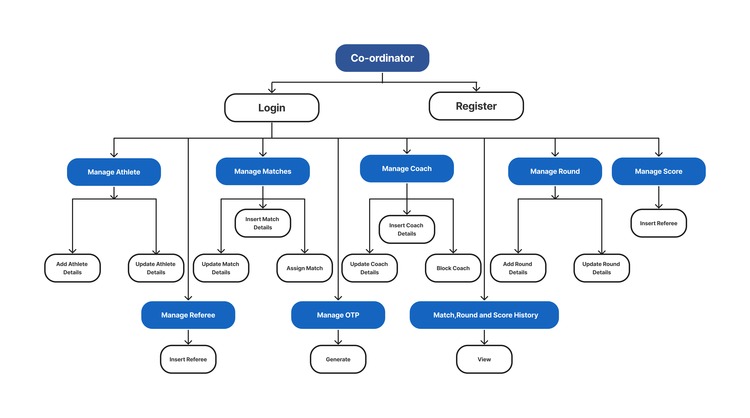

**Chapter7. Testing**

* 1. Unit Testing
* Test Case For Login:

| Test Case ID | Test Field | Condition | Expected Result |
| --- | --- | --- | --- |
| TC-LOGIN-01 | Email | Valid email and correct password | Successful login |
| TC-LOGIN-02 | Email | Valid email but incorrect password | Error message "Invalid credentials" |
| TC-LOGIN-03 | Email | Invalid email format | Error message "Invalid email format" |
| TC-LOGIN-04 | Password | Valid email and password, password encrypted | Successful login |
| TC-LOGIN-05 | Password | Password too short (less than 6 characters) | Error message "Password too short" |

* Test Case For Register:

| Test Case ID | Test Field | Condition | Expected Result |
| --- | --- | --- | --- |
| TC-LOGIN-01 | Email | Valid email and correct password | Successful login |
| TC-LOGIN-02 | Email | Valid email but incorrect password | Error message "Invalid credentials" |
| TC-LOGIN-03 | Email | Invalid email format | Error message "Invalid email format" |
| TC-LOGIN-04 | Password | Valid email and password, password encrypted | Successful login |
| TC-LOGIN-05 | Password | Password too short (less than 6 characters) | Error message "Password too short" |

* Test Case For Forget Password:

| Test Case ID | Test Field | Condition | Expected Result |
| --- | --- | --- | --- |
| TC-FORGET-01 | Email | Valid email registered in the system | Password reset email sent |
| TC-FORGET-02 | Email | Email not registered in the system | Error message "Email not found" |
| TC-FORGET-03 | Email | Invalid email format | Error message "Invalid email format" |

* Test Case For Entry in ACR:

|  |  |  |  |
| --- | --- | --- | --- |
| Test Case ID | Test Field | Condition | Expected Result |
| TC-ADMIN-01 | Email | Valid email format | Accepts valid email format |
| TC-ADMIN-02 | Name | Valid name format | Accepts valid name format |
| TC-ADMIN-03 | Password | Valid password format | Accepts valid password format |
| TC-ADMIN-04 | ImageURL | Valid URL format | Accepts valid URL format |
| TC-ADMIN-05 | Contact | Valid contact format | Accepts valid contact format |
| TC-ADMIN-06 | Status | Valid status format | Accepts valid status format |
| TC-ADMIN-07 | DateOfBirth | Valid date format | Accepts valid date format |
| TC-ADMIN-08 | Age | Valid age | Accepts valid age |
| TC-ADMIN-09 | LastLogin | Valid date format | Accepts valid date format |
| TC-ADMIN-10 | Gender | Valid gender format | Accepts valid gender format |
| TC-ADMIN-11 | City | Valid city format | Accepts valid city format |
| TC-ADMIN-12 | State | Valid state format | Accepts valid state format |
| TC-ADMIN-13 | RoleId | Valid role ID | Accepts valid role ID |
| 12 | Product Name | Valid | Order Details Created Successfully |
| 13 | Tax | Valid | Order Details Created Successfully |
| 14 | Meter | Valid | Order Details Created Successfully |

* Test Case For Tournament:

| Test Case ID | Test Field | Condition | Expected Result |
| --- | --- | --- | --- |
| TC-TOURN-01 | TournamentName | Valid tournament name format | Accepts valid tournament name format |
| TC-TOURN-02 | Venue | Valid venue format | Accepts valid venue format |
| TC-TOURN-03 | TournamentDate | Valid date format | Accepts valid date format |
| TC-TOURN-04 | TournamentCoordinator | Valid coordinator ID | Accepts valid coordinator ID |

* Test Case For Match:

|  |  |  |  |
| --- | --- | --- | --- |
| Test Case ID | Test Field | Condition | Expected Result |
| TC-MATCH-01 | MatchStatus | Valid match status format | Accepts valid match status format |
| TC-MATCH-02 | MatchType | Valid match type format | Accepts valid match type format |
| TC-MATCH-03 | MatchDate | Valid date format | Accepts valid date format |
| TC-MATCH-04 | Gender | Valid gender format | Accepts valid gender format |
| TC-MATCH-05 | AthleteRed | Valid athlete ID | Accepts valid athlete ID |
| TC-MATCH-06 | AthleteBlue | Valid athlete ID | Accepts valid athlete ID |
| TC-MATCH-07 | NextMatchId | Valid next match ID | Accepts valid next match ID |
| TC-MATCH-08 | MatchGroup | Valid match group format | Accepts valid match group format |
| TC-MATCH-09 | Flag | Valid flag format | Accepts valid flag format |
| TC-MATCH-10 | CategoryId | Valid category ID | Accepts valid category ID |
| TC-MATCH-11 | TournamentId | Valid tournament ID | Accepts valid tournament ID |
| TC-MATCH-12 | MatchCoordinator | Valid coordinator ID | Accepts valid coordinator ID |
| TC-MATCH-13 | Referee1 | Valid referee ID | Accepts valid referee ID |
| TC-MATCH-14 | Referee2 | Valid referee ID | Accepts valid referee ID |
| TC-MATCH-15 | Referee3 | Valid referee ID | Accepts valid referee ID |

* 1. Integration Testing
* Integration between Backend and Frontend

|  |  |  |  |
| --- | --- | --- | --- |
| **Test Case ID** | **Description** | **Steps** | **Expected Outcome** |
| INTG-BEFE-01 | Verify login functionality | 1. Enter valid credentials in frontend | User should be authenticated and logged in |
|  |  | 2. Submit login request to backend |  |
|  |  | 3. Backend verifies credentials and responds |  |
|  |  | 4. Frontend receives response and updates UI |  |
| INTG-BEFE-02 | Registration of new viewer | 1. Fill registration form in frontend | New viewer details sent to backend |
|  |  | 2. Submit registration request to backend | Viewer account created in database |
|  |  | 3. Backend responds with success message |  |
|  |  | 4. Frontend confirms successful registration |  |
| INTG-BEFE-03 | Forgot password | 1. Request password reset in frontend | Email sent to registered email address |
|  |  | 2. Frontend sends request to backend | Backend processes request and sends email |
|  |  | 3. User receives password reset instructions |  |

**Chapter8. Future Enhancement**

* Advanced Analytics and Reporting.
* Improved User Management.
* Expanded Features for Coordinators and Coaches
* Enhanced Scoring and Refereeing Tools.
* Enable social media logins and sharing
* Implement tools for data analytics.
* Support multiple languages.

**Chapter9. Glossary**

|  |  |
| --- | --- |
| **Term** | **Definition** |
| **Admin** | A user role responsible for managing categories, tournaments, verifying coordinators, viewing matches and history, and overall administrative tasks within the system. |
| **Athlete** | A participant in the Taekwondo tournament. Athletes are managed by coordinators and can be assigned to matches. |
| **Backend** | The server-side part of the application that handles business logic, database interactions, and API endpoints. For this project, it's implemented using Dotnet Core API. |
| **Category** | A classification used to group athletes based on criteria like weight, age, and gender. |
| **Coach** | A person responsible for training and mentoring athletes. Coaches are managed by coordinators. |
| **Coordinator** | A user role responsible for managing athletes, matches, referees, coaches, scores, and rounds. |
| **Database** | A structured collection of data stored electronically. This project uses SQL Server Management Studio (SSMS) for database management. |
| **Frontend** | The client-side part of the application that interacts with users, displaying data and capturing user inputs. For this project, it's implemented using React and Redux. |
| **JWT Token** | JSON Web Token, a compact, URL-safe means of representing claims to be transferred between two parties. Used for API authentication in the project. |
| **Live Score** | Real-time display of match scores and updates. Implemented using SignalR for live score and round management. |
| **Match** | A competitive event between athletes. Matches are managed by coordinators and can have various statuses and types. |
| **Referee** | A user role responsible for managing scoring during matches. |
| **Round** | A subdivision of a match where athletes compete, and scores are recorded. Rounds are managed by referees and coordinators. |
| **SignalR** | A library for ASP.NET that enables real-time web functionality, allowing server code to push content to connected clients instantly as it becomes available. |
| **SSMS** | SQL Server Management Studio, a software application for configuring, managing, and administering all components within Microsoft SQL Server. |
| **Stored Procedure** | A prepared SQL code that can be saved and reused. In this project, logic is implemented in stored procedures for database operations. |
| **Tournament** | A series of matches held between athletes to determine a champion. Managed by coordinators and administrators. |
| **Viewer** | A user role with the ability to view match scores and updates but without the ability to manage any entities within the system. |
| **Email Services** | Functionality to send emails, used in the project for actions like registration, password reset, and notifications. |
| **Temporary Memory** | In-memory data storage used in the application for performance optimization, caching, or session management. |
| **React** | A JavaScript library for building user interfaces, particularly single-page applications where data can change without a page reload. |
| **Redux** | A predictable state container for JavaScript apps, often used with React to manage application state. |
| **API Authentication** | Process of verifying the identity of a user or process attempting to access the application’s API endpoints, typically using tokens like JWT. |
| **Registration** | The process by which a new user creates an account in the system. |
| **Login** | The process by which a registered user gains access to the system by providing credentials. |
| **Logout** | The process by which a user ends their session in the system. |
| **Forgot Password** | A feature allowing users to reset their password via email if they have forgotten it. |
| **ID** | A unique identifier for records in the database, often set as a primary key. |
| **Primary Key** | A unique identifier for each record in a database table, ensuring that each entry is unique. |
| **Foreign Key** | A field in a database table that creates a link between two tables, enforcing referential integrity. |

**Chapter10. Reference**

* [**https://www.figma.com/**](https://www.figma.com/)
* [**https://mui.com/**](https://mui.com/)
* [**https://learn.microsoft.com/en-us/sql/ssms/tutorials/ssms-configuration?view=sql-server-ver16**](https://learn.microsoft.com/en-us/sql/ssms/tutorials/ssms-configuration?view=sql-server-ver16)
* [**https://jwt.io/**](https://jwt.io/)
* [**https://medium.com/thesignalgroup**](https://medium.com/thesignalgroup)
* [**https://learn.microsoft.com/en-us/aspnet/core/?view=aspnetcore-8.0&WT.mc_id=dotnet-35129-website**](https://learn.microsoft.com/en-us/aspnet/core/?view=aspnetcore-8.0&WT.mc_id=dotnet-35129-website)
* [**https://www.npmjs.com/**](https://www.npmjs.com/)
* [**https://formik.org/docs/overview**](https://formik.org/docs/overview)